**LOCAL**

**Primero, Build Release, pero como Batch Build**

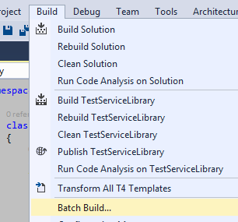

Copy "C:\Proyectos\RPAService\RPAServiceLibrary\bin\Release \RPAServiceLibrary.dll" "C:\Proyectos\Hotbar 2\Hotbar\ServiceLibrary"

Copy

C:\Proyectos\RPAService\RPAServiceLibrary\bin\Release \**RPAServiceLibrary.dll**

C:\Proyectos\Hotbar 2\Hotbar\ServiceLibrary



Commit changes

Luego, si funciona bien copie a servidor

**SERVIDOR**

Publish WebService (not the library)

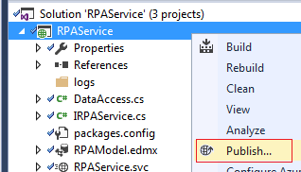

1>Publishing folder /...

1>Publishing folder bin...

1>Web App was published successfully file:///C:/Deploy/RPAService/

1>

========== Build: 0 succeeded, 0 failed, 1 up-to-date, 0 skipped ==========

========== Publish: 1 succeeded, 0 failed, 0 skipped ==========

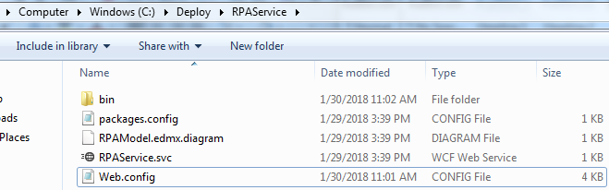

Copy to server orliwv024

Primero a MyDocuments, y luego a E:\WebApps\RPAServiceDev

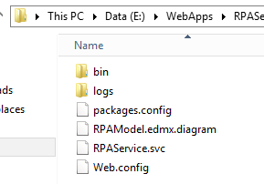

y luego a E:\WebApps\RPAServiceDev

Verifique en web config que esta direccionado a Desarrollo o produccion

Desarrollo : data source=C03DWV010

Produccion : data source=